**Connecting a button**

*Button needed to be pressed and hold*

const int buttonPin = 2;

const int ledPin = 9;

int buttonState = 0;

bool ledState = false;

unsigned long lastDebounceTime = 0;

unsigned long debounceDelay = 50;

void setup() {

  pinMode(ledPin, OUTPUT);

  pinMode(buttonPin, INPUT_PULLUP);

}

void loop() {

  int reading = digitalRead(buttonPin);

  if (reading == LOW) {

    reading = HIGH;

  } else {

    reading = LOW;

  }

  if (reading != buttonState) {

    lastDebounceTime = millis();

  }

  if ((millis() - lastDebounceTime) > debounceDelay) {

    if (reading != ledState) {

      ledState = reading;

      digitalWrite(ledPin, ledState ? HIGH : LOW);

    }

  }

  buttonState = reading;

}

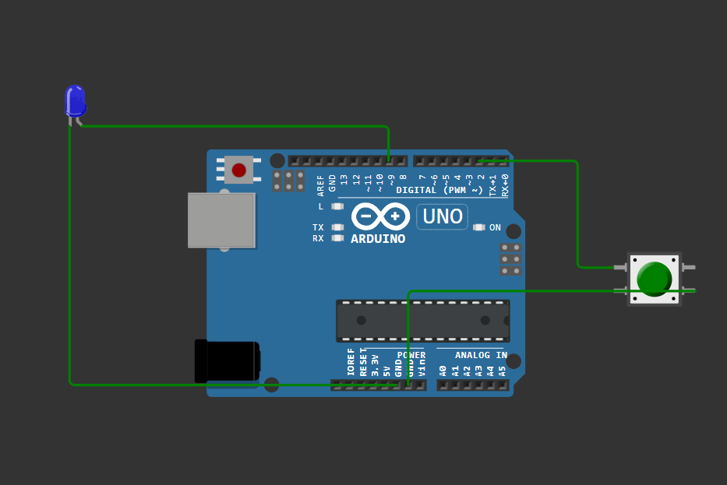

*Button is not pressed, light is off*

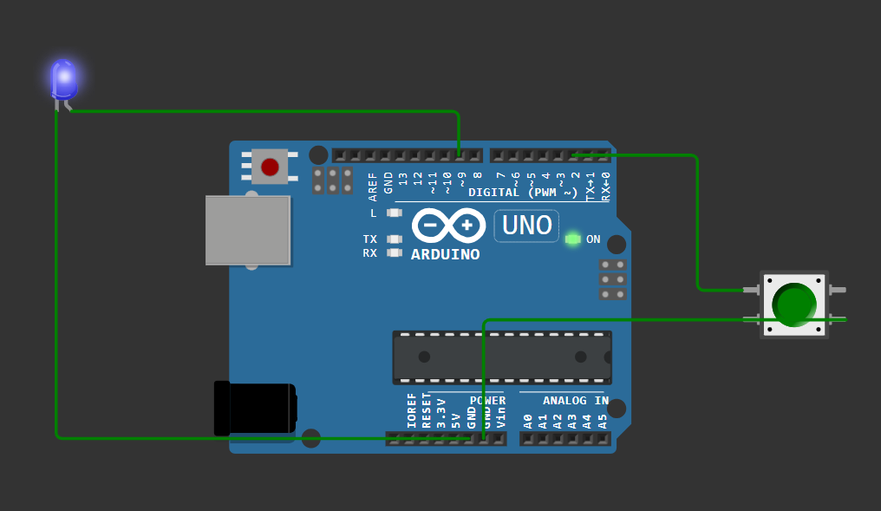

*Button is pressed and hold, light is on*

*Button only needs one push*

const int buttonPin = 2;

const int ledPin = 9;

int buttonState;

int lastButtonState = LOW;

bool ledState = false;

unsigned long lastDebounceTime = 0;

unsigned long debounceDelay = 50;

void setup() {

  pinMode(ledPin, OUTPUT);

  pinMode(buttonPin, INPUT_PULLUP);

}

void loop() {

  int reading = digitalRead(buttonPin);

  if (reading != lastButtonState) {

    lastDebounceTime = millis();

  }

  if ((millis() - lastDebounceTime) > debounceDelay) {

    if (reading == LOW && buttonState == HIGH) {

      ledState = !ledState;

      digitalWrite(ledPin, ledState ? HIGH : LOW);

    }

    buttonState = reading;

  }

  lastButtonState = reading;

}

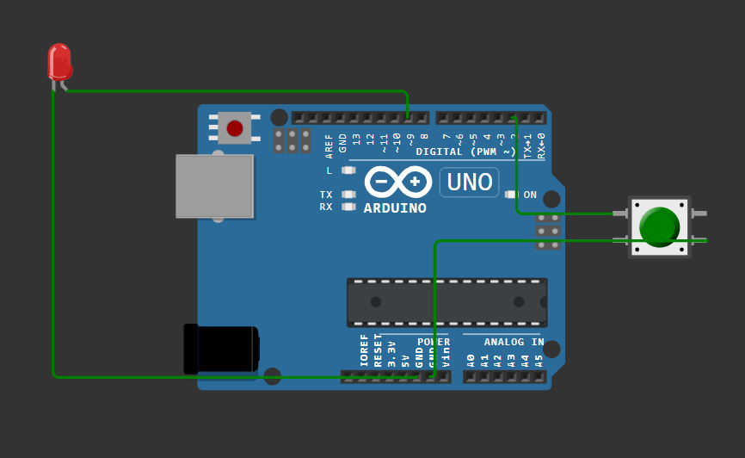

*Light is off before push*

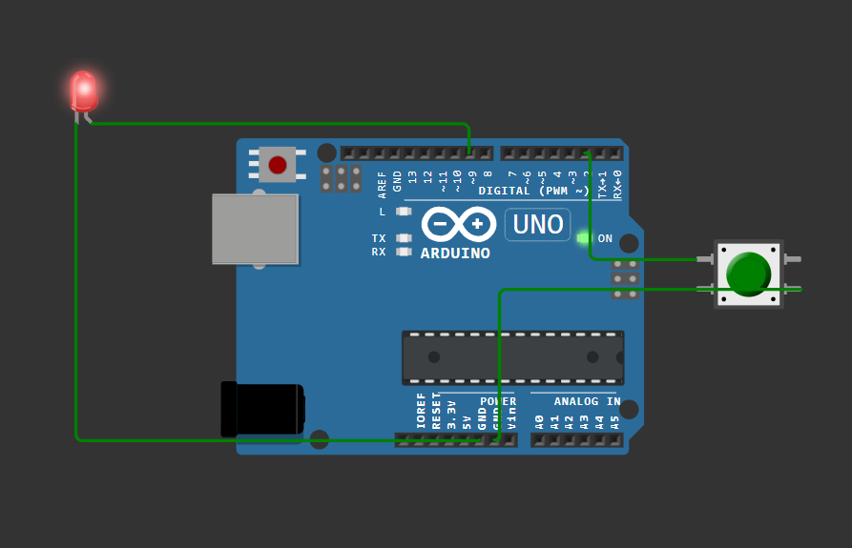

*Light is on after push*

**Button with resistor**

#define BUTTON_PIN 4

void setup()

{

Serial.begin(9600);

pinMode(BUTTON_PIN, INPUT_PULLUP);

}

void loop()

{

byte buttonState = digitalRead(BUTTON_PIN);

if (buttonState == LOW) {

Serial.println("Button is pressed");

}

else {

Serial.println("Button is not pressed");

}

delay(1000);

}

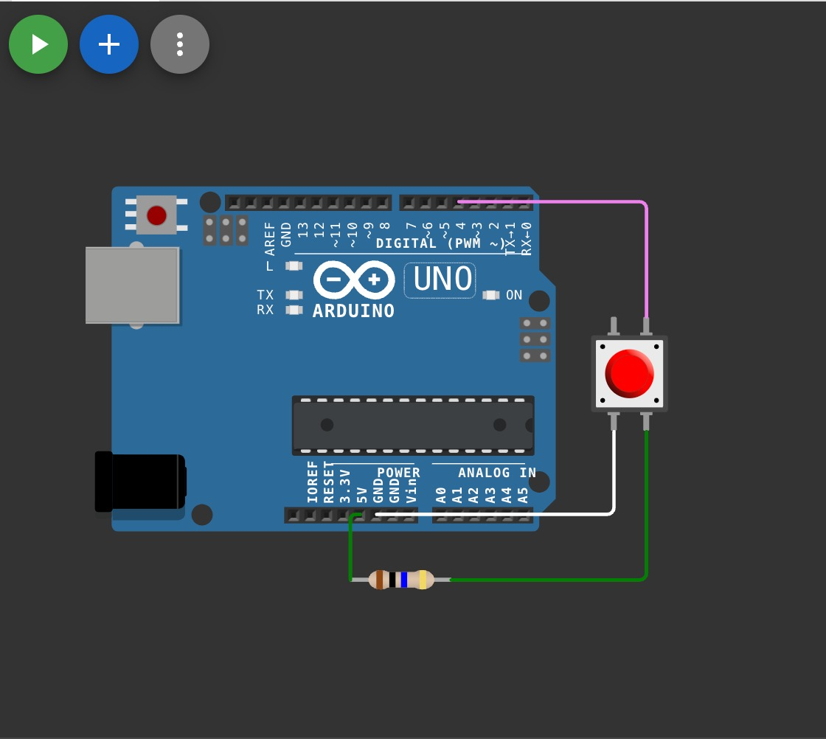

**Button with Resistor**

#define BUTTON_PIN 4

void setup()

{

Serial.begin(9600);

pinMode(BUTTON_PIN, INPUT_PULLUP);

}

void loop()

{

byte buttonState = digitalRead(BUTTON_PIN);

if (buttonState == HIGH) {

Serial.println("Button is pressed");

}

else {

Serial.println("Button is not pressed");

}

delay(1000);

}

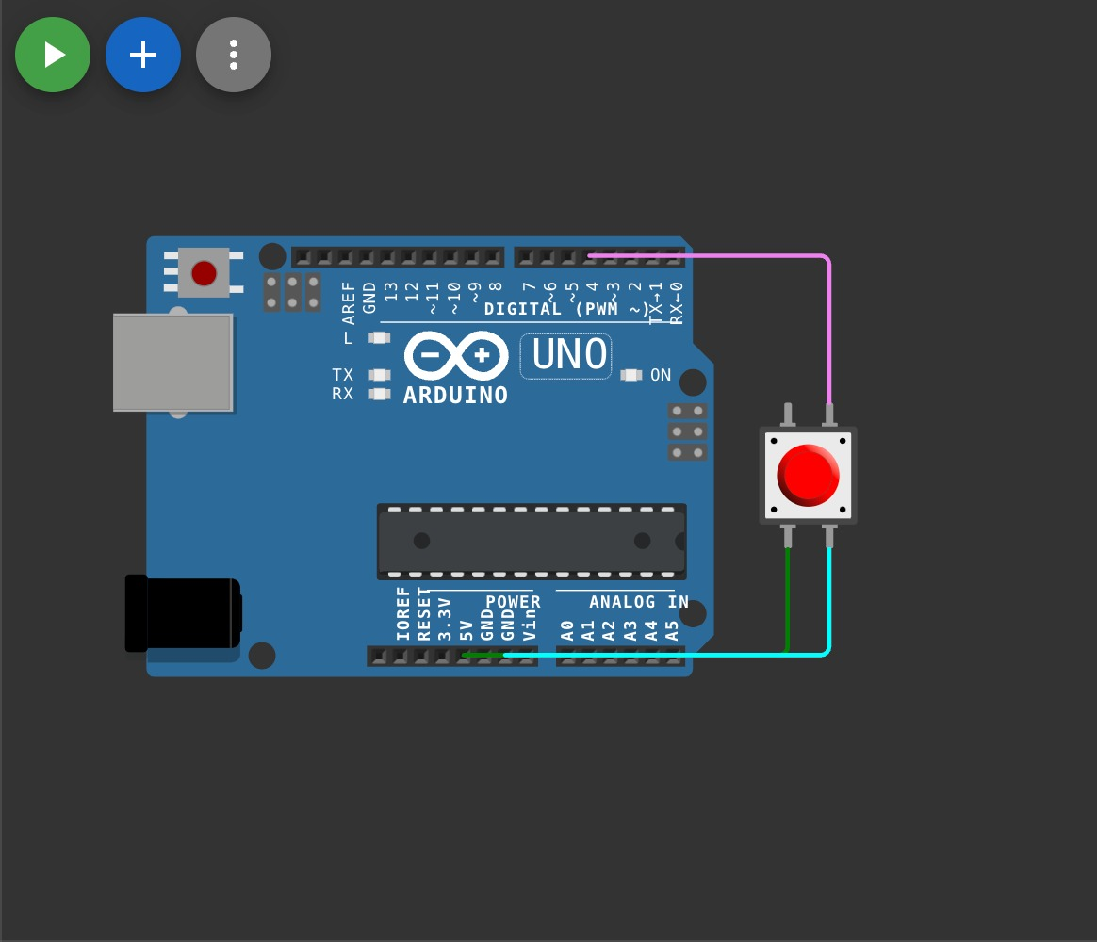

**Bounce Part**

#define BUTTON_PIN 4

byte lastButtonState = LOW;

void setup() {

Serial.begin(9600);

pinMode(BUTTON_PIN, INPUT);

}

void loop() {

byte buttonState = digitalRead(BUTTON_PIN);

if (buttonState != lastButtonState) {

lastButtonState = buttonState;

if (buttonState == LOW) {

Serial.println("Button released");

}

}

}

**Debounce Part**

#define BUTTON_PIN 4

byte lastButtonState = LOW;

unsigned long debounceDuration = 50; // millis

unsigned long lastTimeButtonStateChanged = 0;

void setup() {

Serial.begin(9600);

pinMode(BUTTON_PIN, INPUT);

}

void loop() {

if (millis() - lastTimeButtonStateChanged > debounceDuration) {

byte buttonState = digitalRead(BUTTON_PIN);

if (buttonState != lastButtonState) {

lastTimeButtonStateChanged = millis();

lastButtonState = buttonState;

if (buttonState == LOW) {

Serial.println("Button released");

}

}

}

}